1

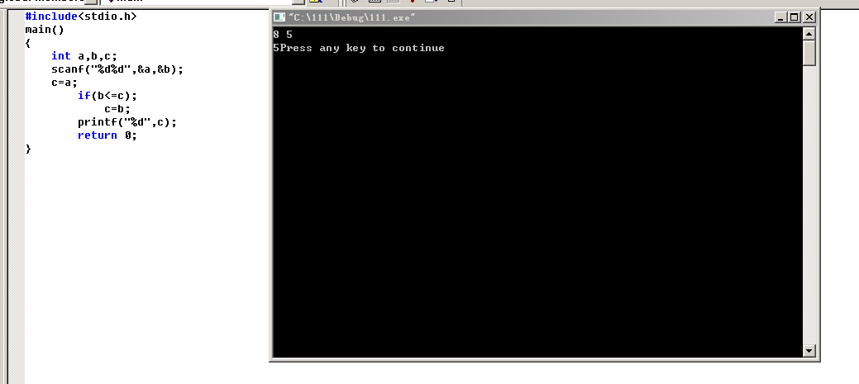

#include<stdio.h>

int main()

{

int a,b,c;

scanf("%d%d",&a,&b);

c=a;

if(b<=c);

c=b;

printf("%d",c);

return 0;

3

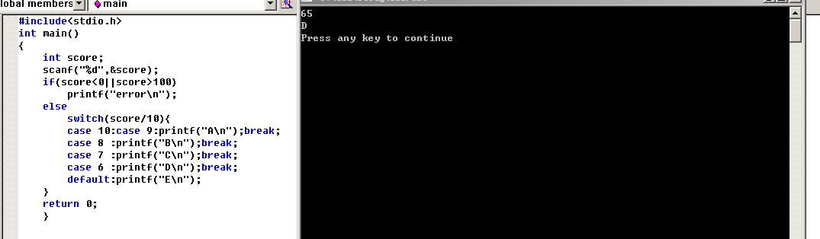

#include<stdio.h>

int main()

{

int score;

scanf("%d",&score);

if(score<0||score>100)

printf("error\n");

else

switch(score/10){

case 10:case 9:printf("A\n");break;

case 8 :printf("B\n");break;

case 7 :printf("C\n");break;

case 6 :printf("D\n");break;

default:printf("E\n");

}

return 0;

}